Sam McDowell

7/15/2020

Lab 5.3

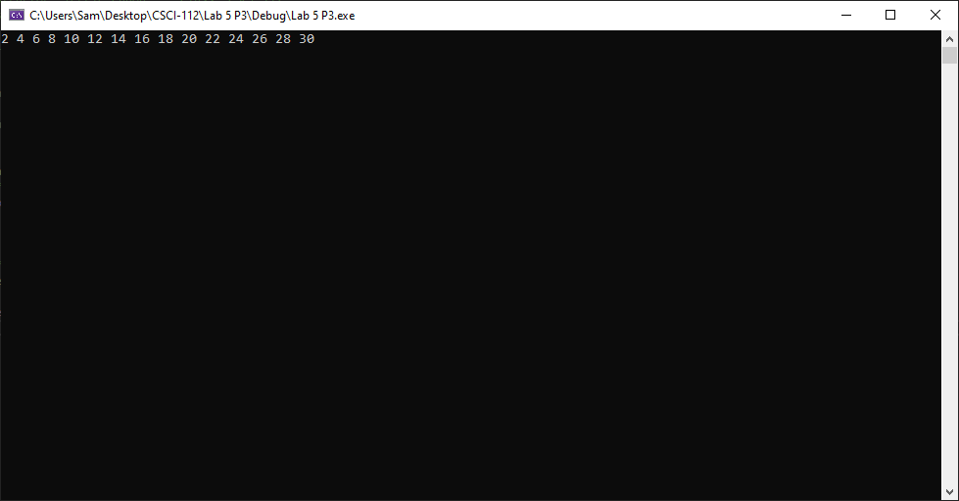

# Transcription:

2 4 6 8 10 12 14 16 18 20 22 24 26 28 30